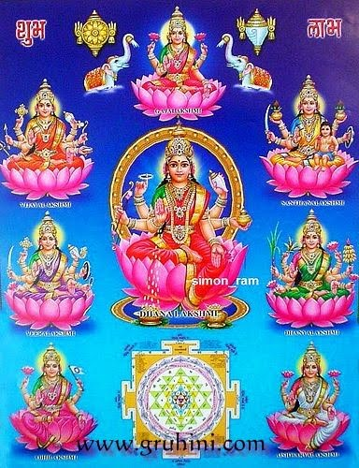

https://www.hindufaqs.com/ashta-lakshmi-the-eight-manifestations-of-goddess-lakshmi/
1.Adi-Lakshmi or Maha Lakshmi (The Great Goddess)
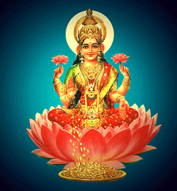
Adi-Lakshmi also known as Maha-Lakshmi or “The Great Lakshmi is a first form of Goddess Lakshmi. She is daughter of sage Bhrigu and wife of Lord Vishnu or Narayana. Aadi-Lakshmi is often depicted as the consort of Narayana living with him at his home in Vaikuntha.

2. Dhana-Lakshmi or Aishwarya Lakshmi (The Goddess of Prosperity and Wealth)
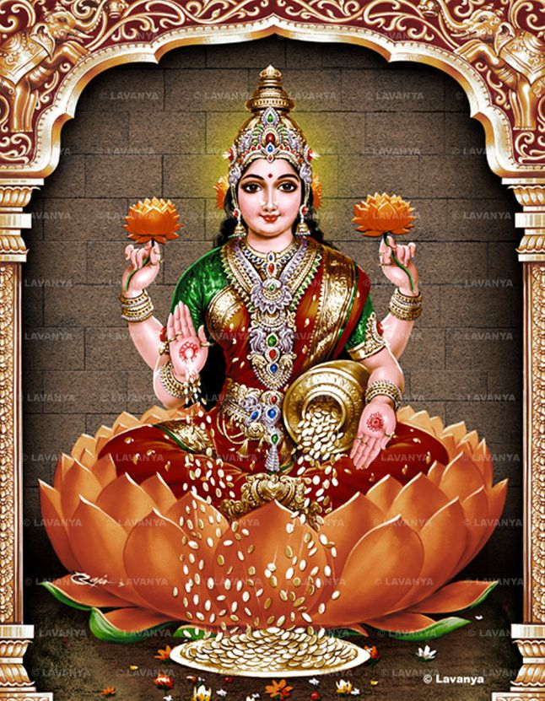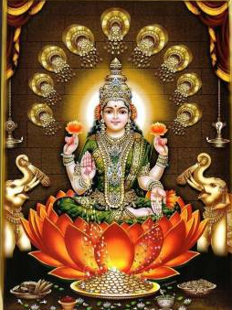
Dhana means wealth in the form of money or gold. It also represents inner strength, will power, talent, virtues and character. Dhana-Lakshmi represents intangible aspect of the human world. She is said to bless the followers with abundance of wealth and prosperity.
3. Dhanya-Lakshmi (Goddess of Food grains)
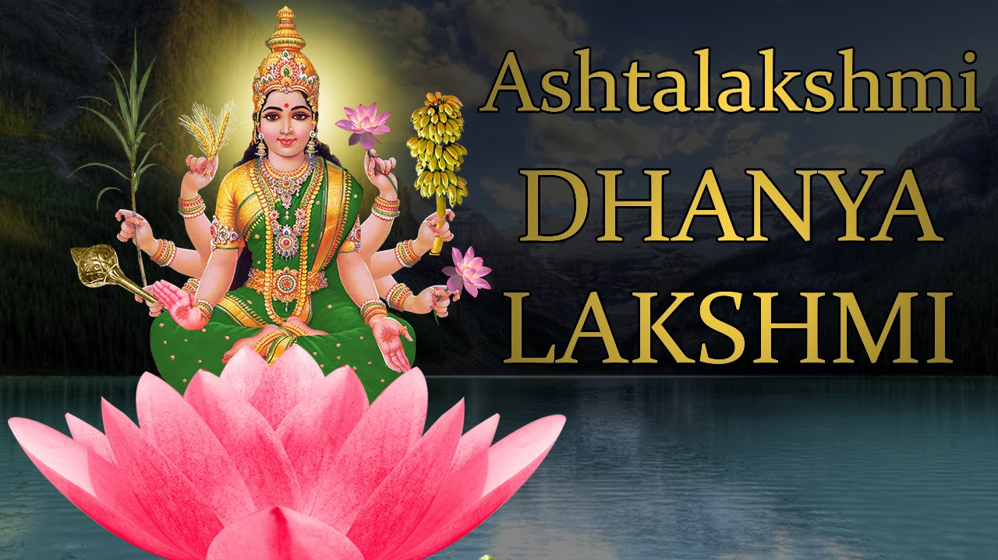
The third forms of Goddess Lakshmi in Ashta-Lakshmi Dhanya Lakshmi. Dhanya is food grains – full of natural nutrients and minerals required for a healthy body and mind.
She is the giver of agricultural wealth and all-important nourishment for human beings.
4. Gaja-Lakshmi (The Elephant Goddess)
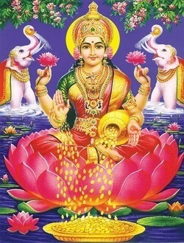
The fourth form of Goddess Lakshmi is Gaja-Lakshmi or “Elephant Lakshmi”. She was born out of Samudra Manthan. She is the daughter of the ocean. Myths have it that Gaja-Lakshmi helped Lord Indra regain his lost wealth from the depth of the ocean.
This form of Goddess Lakshmi is the bestower and protector of wealth, prosperity, grace, abundance, and royalty.
5. Santana-Lakshmi (The Goddess of Progeny)
The fifth form of Goddess Lakshmi is Santana Lakshmi. She is the Goddess of progeny, the treasure of the family life. Worshipers of Santana Lakshmi are bestowed with the wealth of good children possessing with good health and a long life.
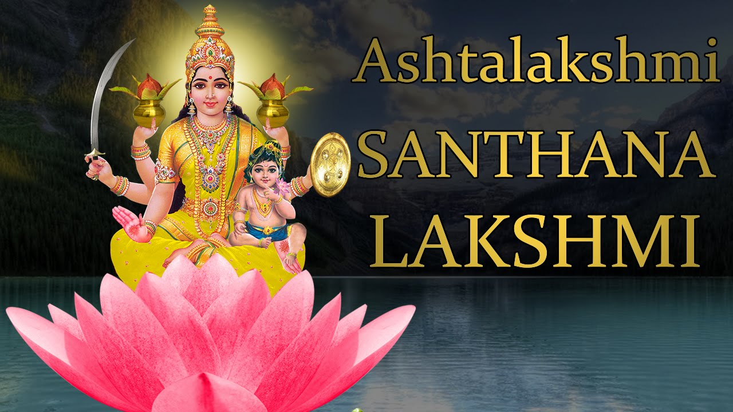
6. Veera-Lakshmi or Dhairya Lakshmi (The Goddess of Valor and Courage)
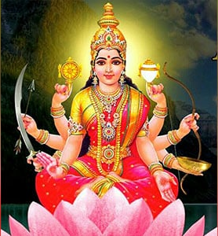
The sixth form of Goddess Lakshmi is Veera Lakshmi. As the names suggests (Veera = valor or courage). This form of Goddess Lakshmi symbolizes of courage and strength, and power.
Veera-Lakshmi is worshiped to gain valor and strength and to overcome the difficulties of life, and lead a life of stability.
7. Vidya-Lakshmi (The Goddess of Knowledge)
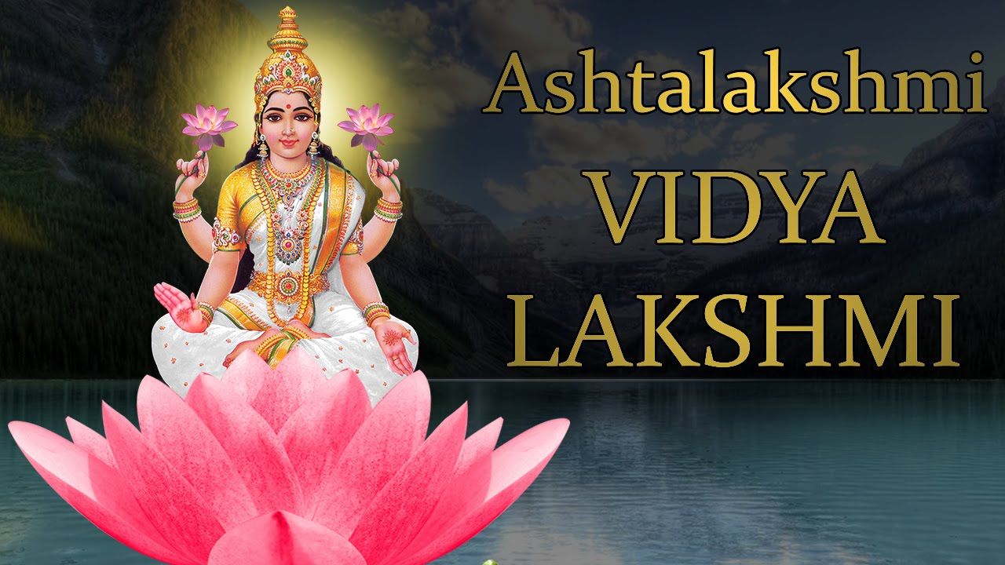
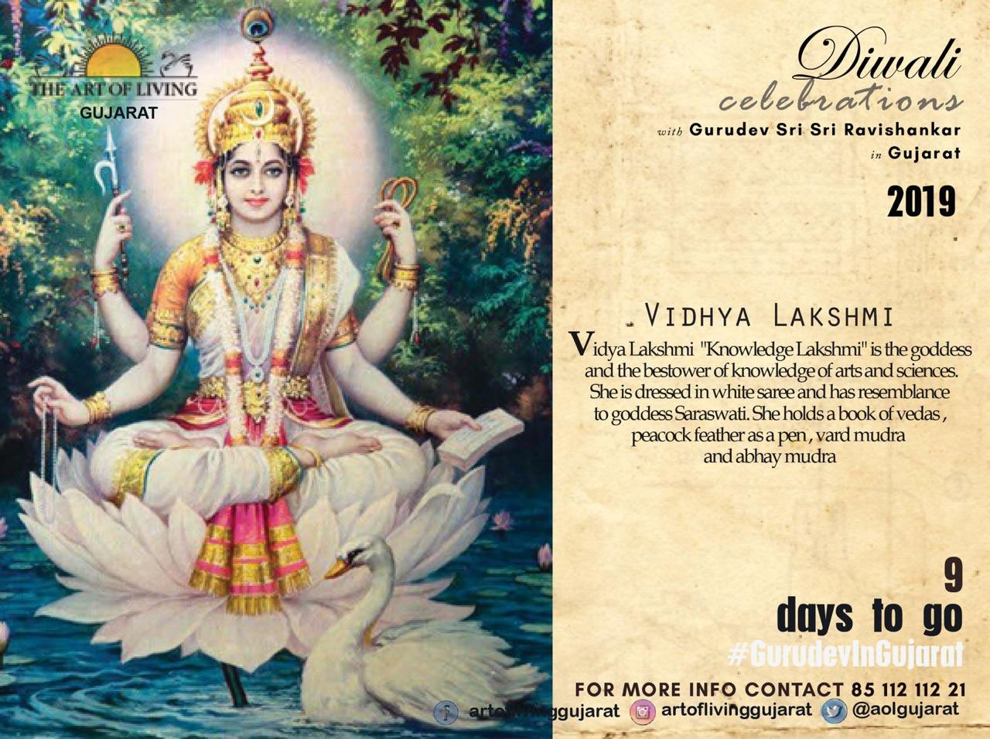

The Seventh form of Goddess Lakshmi is Vidya Lakshmi. Vidya means knowledge as well as education.
This form of Goddess Lakshmi is the giver of knowledge of the arts and sciences.
8. Vijaya-Lakshmi or Jaya Lakshmi (The Goddess of Victory)
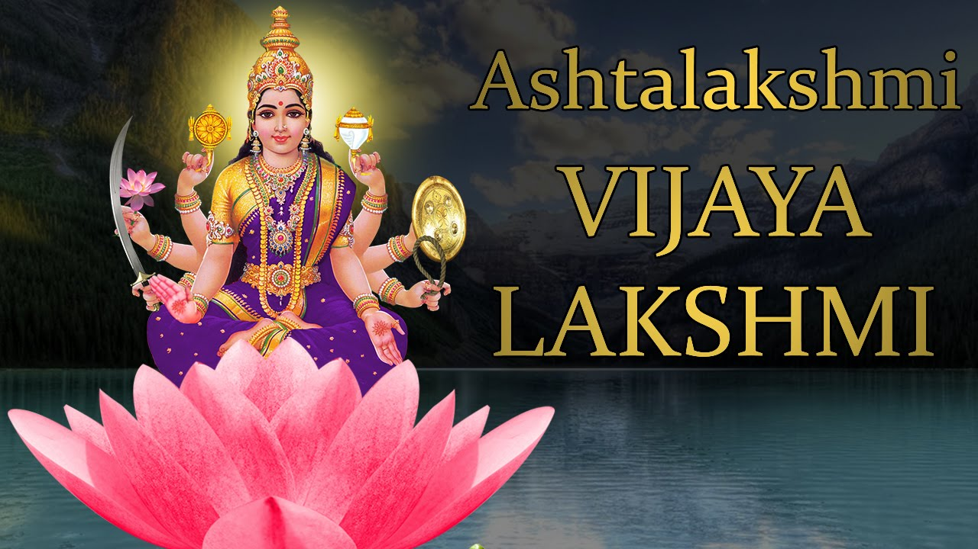
The Eighth form of Goddess Lakshmi is Vijaya Lakshmi. Vijaya means victory. So, this form of Goddess Lakshmi symbolizes victory in all aspects of life. Vijaya-Lakshmi is worshiped to ensure all-round victory in every aspect of life.

Dhanalakshmi
Vidya Lakshmi
Veera lakshmi

Santhana lakshmi
vijayalakshmi

Dhanyalakshmi
Adi lakshmi
Baby of Santana lakshmi
Gajalakshmi

